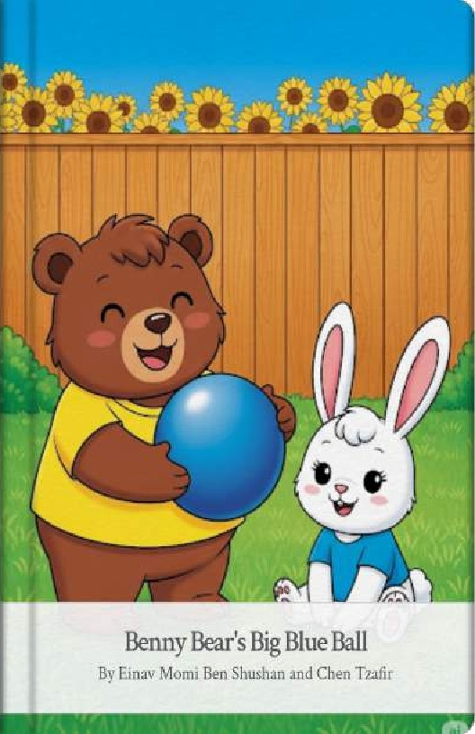
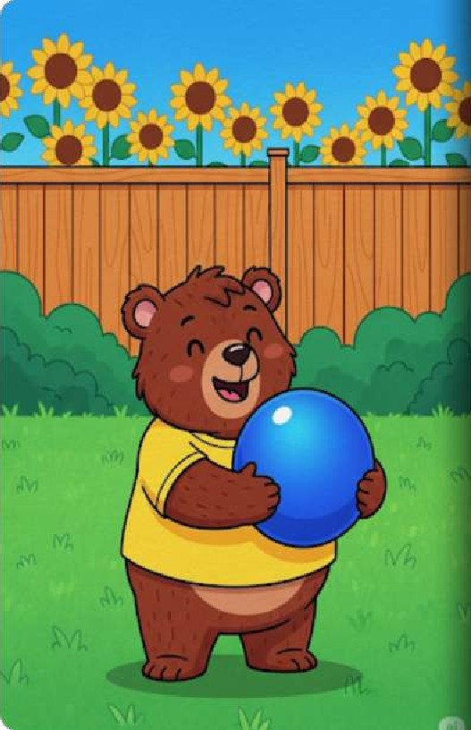
Look at Benny Bear! He is in his bright, sunny backyard. Benny has something very special. It isa big, vibrant blue ball, Benny loves his ball very much,
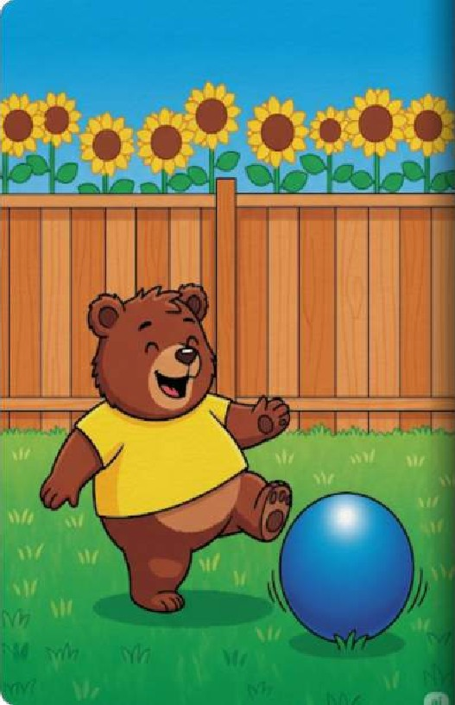
Boing, boing, boingl Benny bounces the ball on the soft grass. The ball goes up and the ball goes down, Benny laughs as he plays.

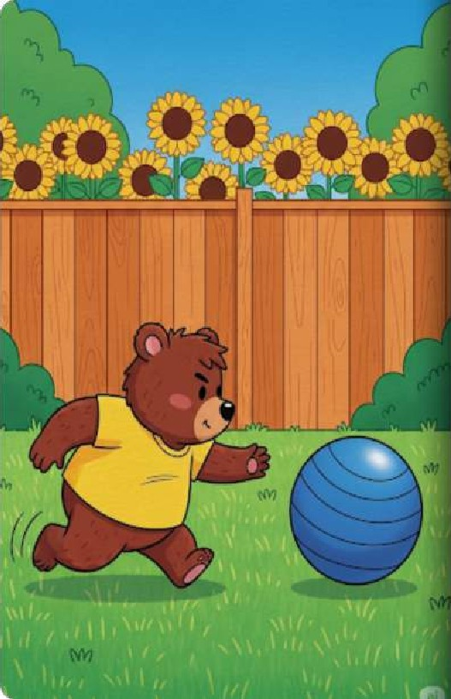
Oh no! The ball rolls away. It rolls past the yellow sun-flowers. It rolls toward the tall wooden fence, Benny trots after it as fast as he can.
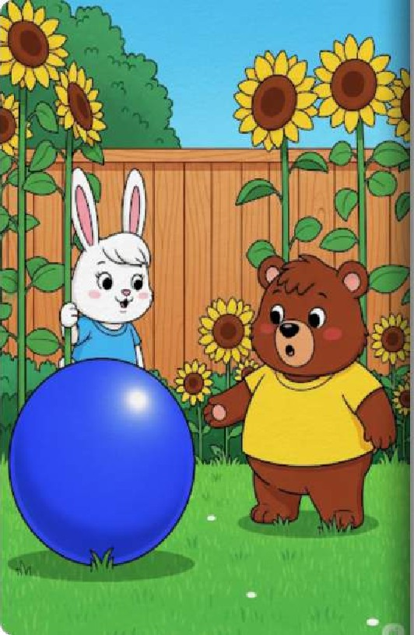
Who is hiding behind the flowers? It is Clover the bunny! Clover has long ears and a little pink nose, She sees Benny and his big blue ball,
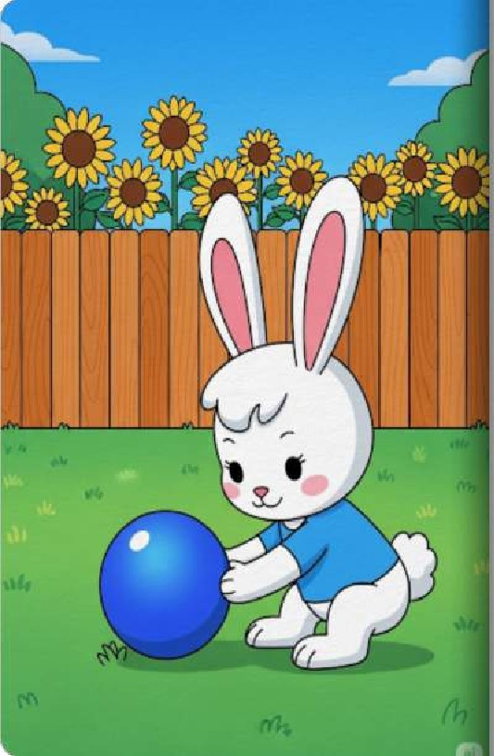
Clover wants to play too. She gives the ball a gentle nudge with her nose. The ball rolls back to Benny, Roll, balli roll!

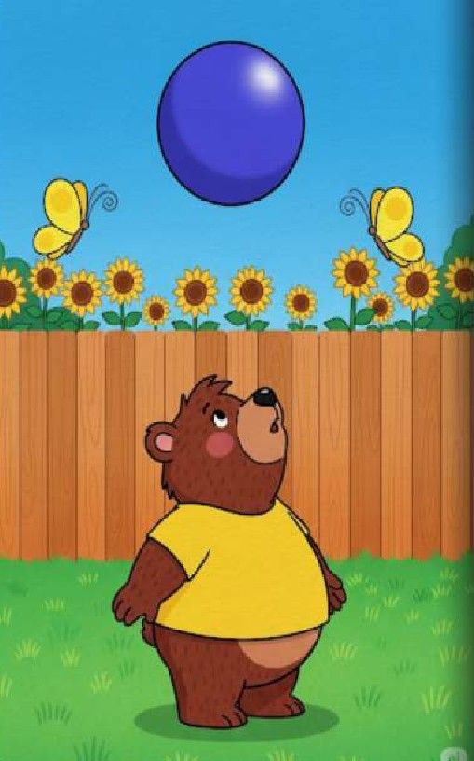
Benny throws the ball high into the bright sky. He looks up and sees two yellow butterflies fluttering near che fence. They are dancing in the air.
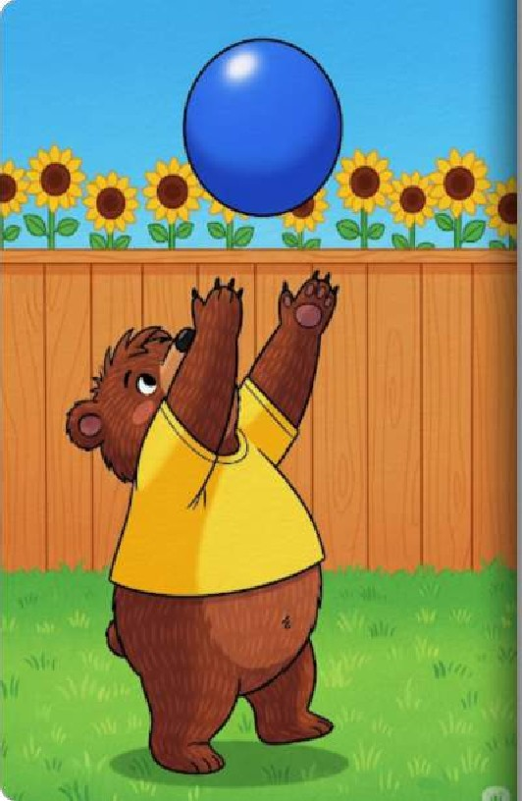
The ball comes back down. Benny reaches vp high, He wants to catch the big blue ball before it hits the ground.
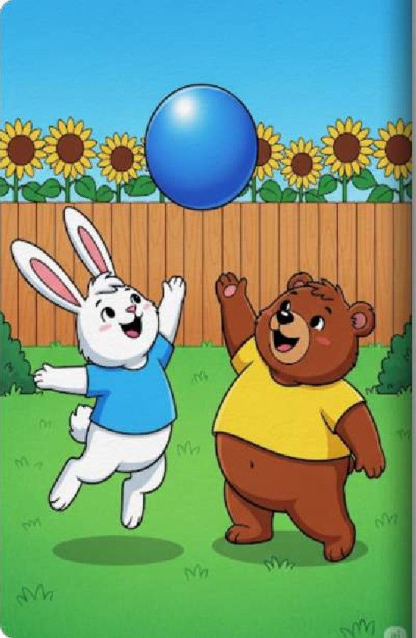
Clover jumps high into the air! She is a very good jumper. She tries to help Benny catch the ball
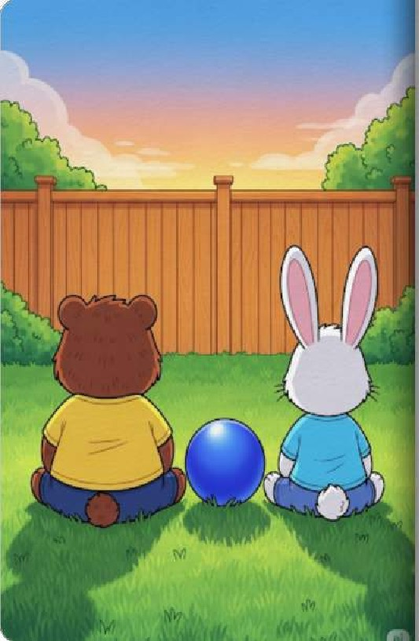
The sun begins to set, turning the sky orange and pink. Benny and Clover are tired from playing. They sit together and rest, Goodnight, Benny Goodnight, Clover.
10

